100 kVA/80 kW UPS POWER POD
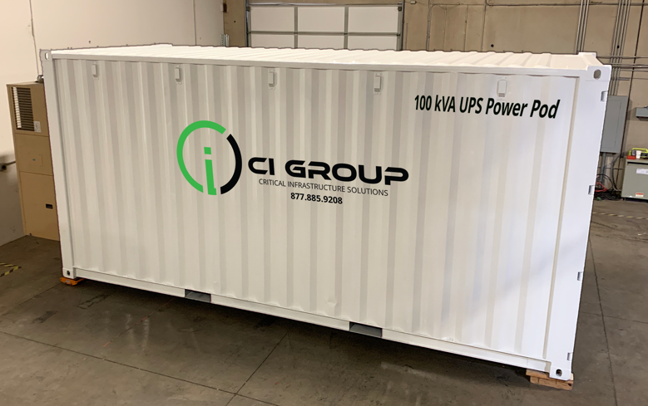

          - 100 kVA UPS Power POD
    - Input & Output Switchgear
    - Pre-wired: Input & Output Cam Locks
    - N+1 HVAC: Cooling Redundancy

UPS INFORMATION
Manufacturer | Mitsubishi
Series/Model | 9700 Series Model 150
Rating kVA KW | 100 kVA / 80 KW
Input Voltage | 480V 4W +G
Input Wiring (required on site) | (2) Set 4/0 Cam Lock Connections
Output Voltage | 480V 4W +G
Output Wiring (required on site) | (2) Set 4/0 Cam Lock Connections
Wrap-Around Maintenance Bypass | With Kirk Key and Solenoid Key Release
UPS BATTERY INFORMATION
Battery Type | Enersys HX 12-400
Estimated Battery Run-Time | 8 Minutes (Standard) – extended runtime options are available.
HVAC INFORMATION
Manufacturer | AirSys
Number of A/C Units | 2
Tonnage Capacity: Per Unit | 4 Ton
Total Tonnage Capacity | 8 Ton

